**9 SCIENCE 2016**

### BIOLOGY TEST TWO

Name: ____________________ Teacher: ___________________ Mark: /49

**Percentage: %**

**SECTION A: MULTIPLE CHOICE (10 marks)**

**Please circle your answer on the multiple choice answer grid below.**

1. A B C D

2. A B C D

3. A B C D

4. A B C D

5. A B C D

6. A B C D

7. A B C D

8. A B C D

9. A B C D

10. A B C D

Questions 1-3 are based on the food web below.

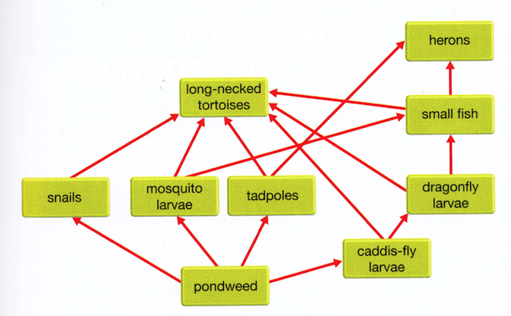

**1.** Identify which of the following relationships in the table are correct.

|  |  |  |
| --- | --- | --- |
| Answer | Predation | Competition |
| (a) | Small fish and mosquito larvae | Tadpoles and dragonfly larvae |
| (b) | Snails and pondweed | Heron and small fish |
| (c) | Heron and small fish | Heron and long-necked tortoise |
| (d) | Long-necked tortoise and tadpoles | Tadpoles and small fish |

**2.** If the lake was sprayed with a chemical to kill the mosquitos, identify the most likely effect.

(a) The amount of pondweed would decrease.

(b) The tadpole population would decrease.

(c) Most of the herons would migrate out of the area.

(d) The population of small fish would decrease.

**3.** If a disease killed most of the long-necked tortoises, identify a likely short-term change in the

ecological system.

(a) Rapid increase in the numbers of small fish.

(b) Decrease in the numbers of heron.

(c) Rapid increase in the biomass of pondweed.

(d) No change in the biomass of caddis-fly larvae.

**4.** Select the abiotic factors below:

(a) temperature, predation, water.

(b) competition, soil type, fire.

(c) water, fire, temperature.

(d) soil type, parasitism, sunlight.

**5.** Your body sweating when you are hot is an example of:

(a) a functional adaptation.

(b) a behavioural adaptation.

(c) a structural adaptation.

(d) an environmental adaptation.

**6.** A bat having wings is an example of:

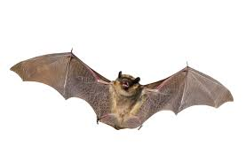

(a) an environmental adaptation.

(b) a behavioural adaptation.

(c) a functional adaptation.

(d) a structural adaptation.

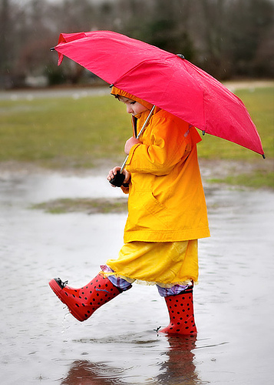**7.** Using an umbrella when it is raining is an example of:

(a) a behavioural adaptation.

(b) a structural adaptation.

(c) a functional adaptation.

(d) an environmental adaptation.

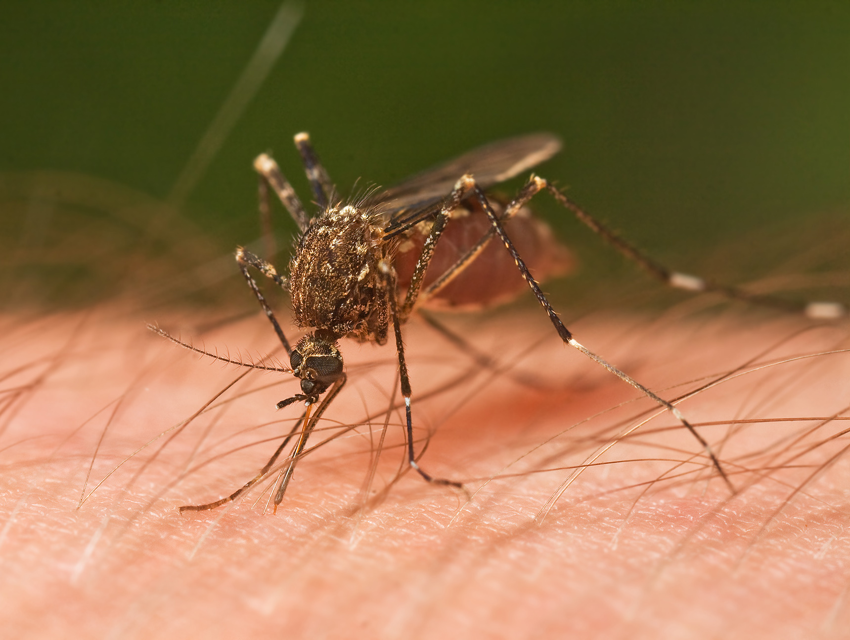**8.** This mosquito sucking the blood of a human is an example of:

(a) competition.

(b) decomposing.

(c) parasitism.

(d) predation.

Questions 9 and 10 are based on the image below.

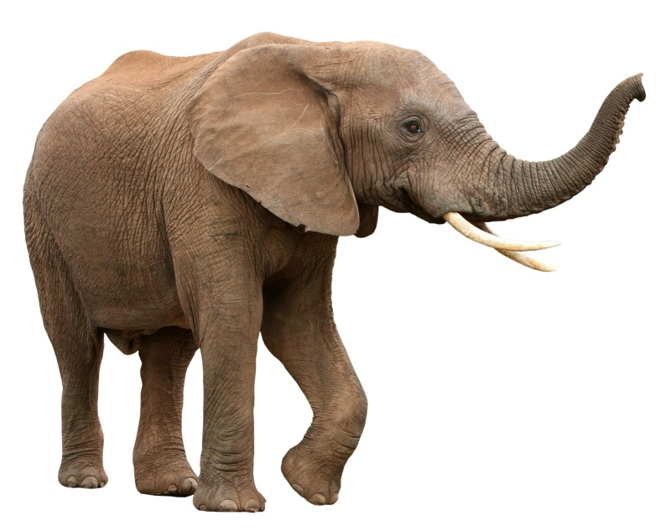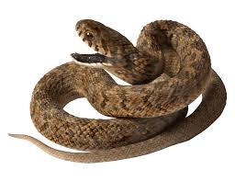

**9.** The following organisms are endothermic:

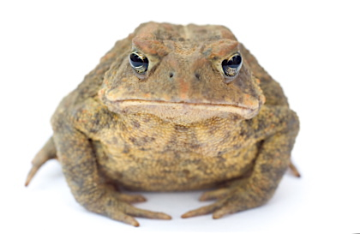(a) A, D and E.

C

A

(b) F, E and A.

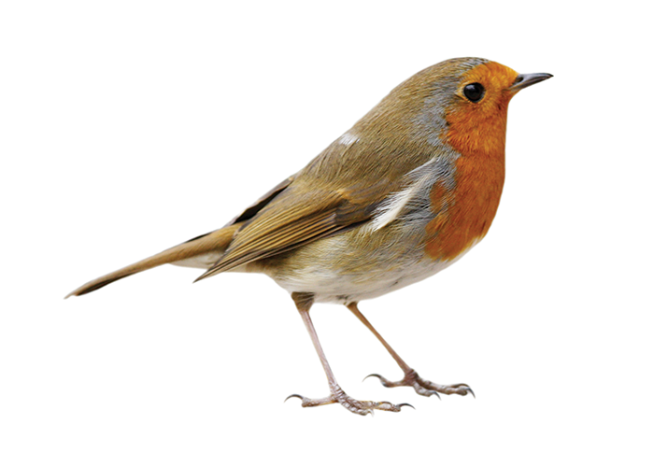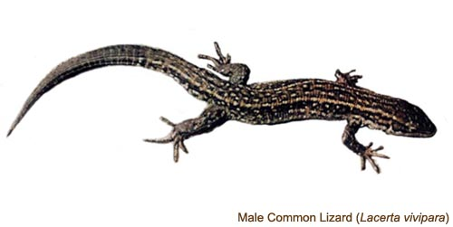(c) C, A and B.

(d) A, D and F.

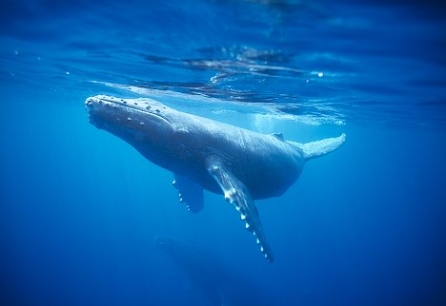

B

G

**10.** The following organisms are ectothermic.

D

(a) C, E and G.

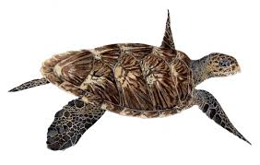(b) C, D and G.

(c) C, B and G.

(d) B, D and F.

E

F

**SECTION B: SHORT ANSWER (36 marks)**

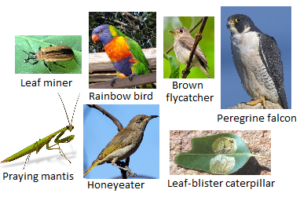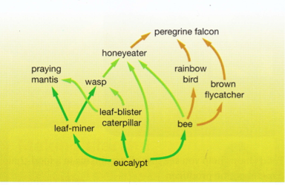**1.** Look at the food web below and answer the following questions. (11 marks)

**a)** State the name of the producer: ______________________________________________________

**b)** State the name of a herbivore: _______________________________________________________

**c)** State the name of two carnivores: _____________________________________________________

**d)** List three animals that compete for bees as a food source:

____________________________________________________________________________________

**e)** List two animals that compete for leaf-miners as a food source.

____________________________________________________________________________________

**f)** Write an example of a predator and prey.

Predator: __________________________ Prey: _____________________________

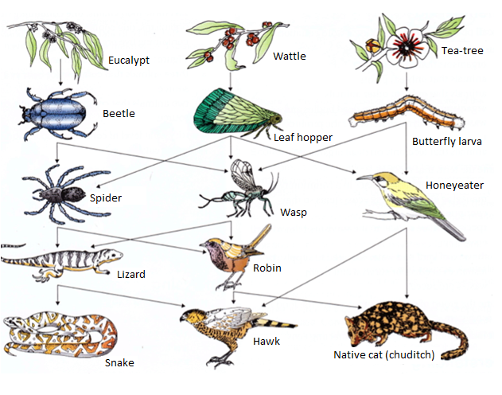**2.** Look at the food web and answer the

following question.

(8 marks)

If the amount of wattle increased, describe what you think would happen to each of the following populations and explain why.

**a)** Leaf hoppers: _____________________________________________________________________

____________________________________________________________________________________

____________________________________________________________________________________

____________________________________________________________________________________

____________________________________________________________________________________

**b)** Wasps: __________________________________________________________________________

____________________________________________________________________________________

____________________________________________________________________________________

____________________________________________________________________________________

____________________________________________________________________________________

**c)** Honeyeaters: _____________________________________________________________________

____________________________________________________________________________________

____________________________________________________________________________________

____________________________________________________________________________________

____________________________________________________________________________________

**d)** Beetles: __________________________________________________________________________

____________________________________________________________________________________

____________________________________________________________________________________

____________________________________________________________________________________

____________________________________________________________________________________

**3.**  Write the correct letter next to the matching description. (12 marks)

|  |  |  |
| --- | --- | --- |
| Term | Description | Matching letter |
| **a)** Predator | Close and often long-term interaction between two or more  different biological species. |  |
| **b)** Habitat | Organisms that require a ready-made source of food. |  |
| **c)** Ecologist | The organism killing and eating another organism. |  |
| **d)** Parasitism | The animal being killed and eaten. |  |
| **e)** Producers | An area of the Earth made up of all the organisms and abiotic  factors within its boundaries. |  |
| **f)** Host | An example of a symbiotic relationship. |  |
| **g)** Symbiosis | The organism that a parasite lives off. |  |
| **h)** Consumers | The organism that usually harms or sometimes kills the host. |  |
| **i)** Parasite | Organisms that make food for the community. |  |
| **j)** Prey | Someone who studies ecology. |  |
| **k)** Ecological system | All the factors in an organism’s surroundings that affect it. |  |
| **l)** Environment | Where an organism lives. |  |

|  |  |
| --- | --- |
| Invasive species | Number of mammal species  that were threatened |
| Rabbits | 11 |
| Pigs | 2 |
| Cats | 24 |
| Foxes | 20 |
| Goats | 4 |

**4.** In Australia, in 2002, the number of mammal

species that were threatened by invasive

animals was recorded. The table on the right

shows the data recorded.

**a)** Draw a graph using the data in the table. (5 marks)

